**Scenario 1:**

CREATE OR REPLACE PROCEDURE ProcessMonthlyInterest IS

BEGIN

FOR acc IN (SELECT account_id, balance FROM savings_accounts) LOOP

UPDATE savings_accounts

SET balance = balance + (balance * 0.01)

WHERE account_id = acc.account_id;

END LOOP;

COMMIT;

END;

/

EXEC ProcessMonthlyInterest;

**OUTPUT:**

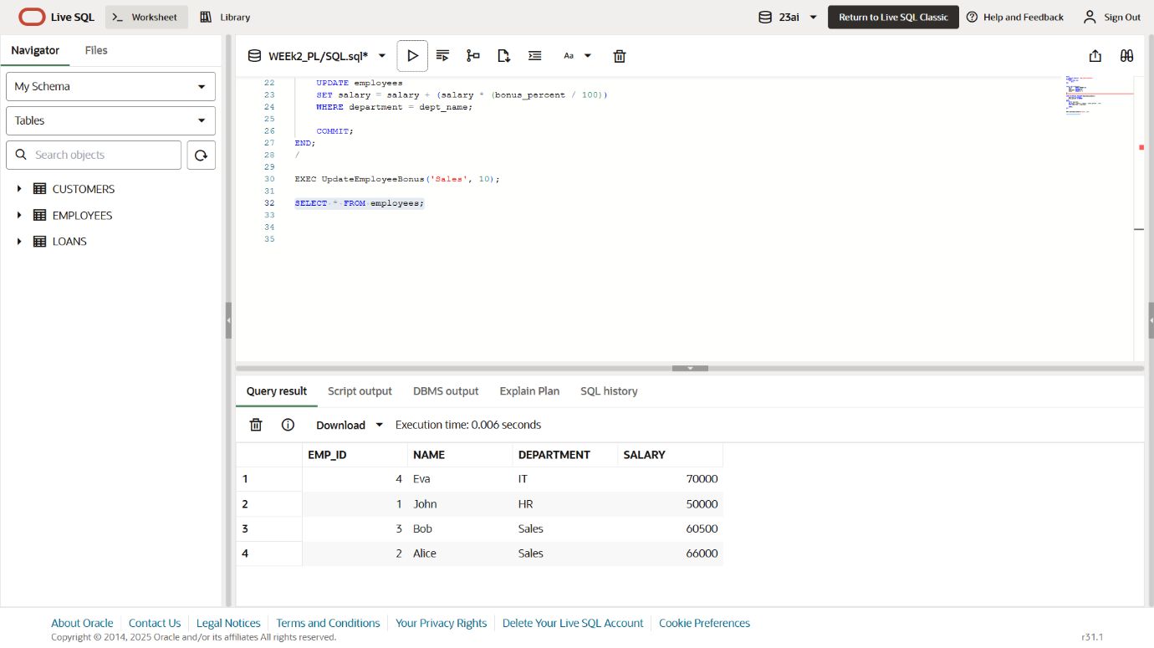

**Scenario 2:**

CREATE OR REPLACE PROCEDURE UpdateEmployeeBonus (

dept_name IN VARCHAR2,

bonus_percent IN NUMBER

) IS

BEGIN

UPDATE employees

SET salary = salary + (salary * (bonus_percent / 100))

WHERE department = dept_name;

COMMIT;

END;

/

EXEC UpdateEmployeeBonus('Sales', 10);

**OUTPUT:**

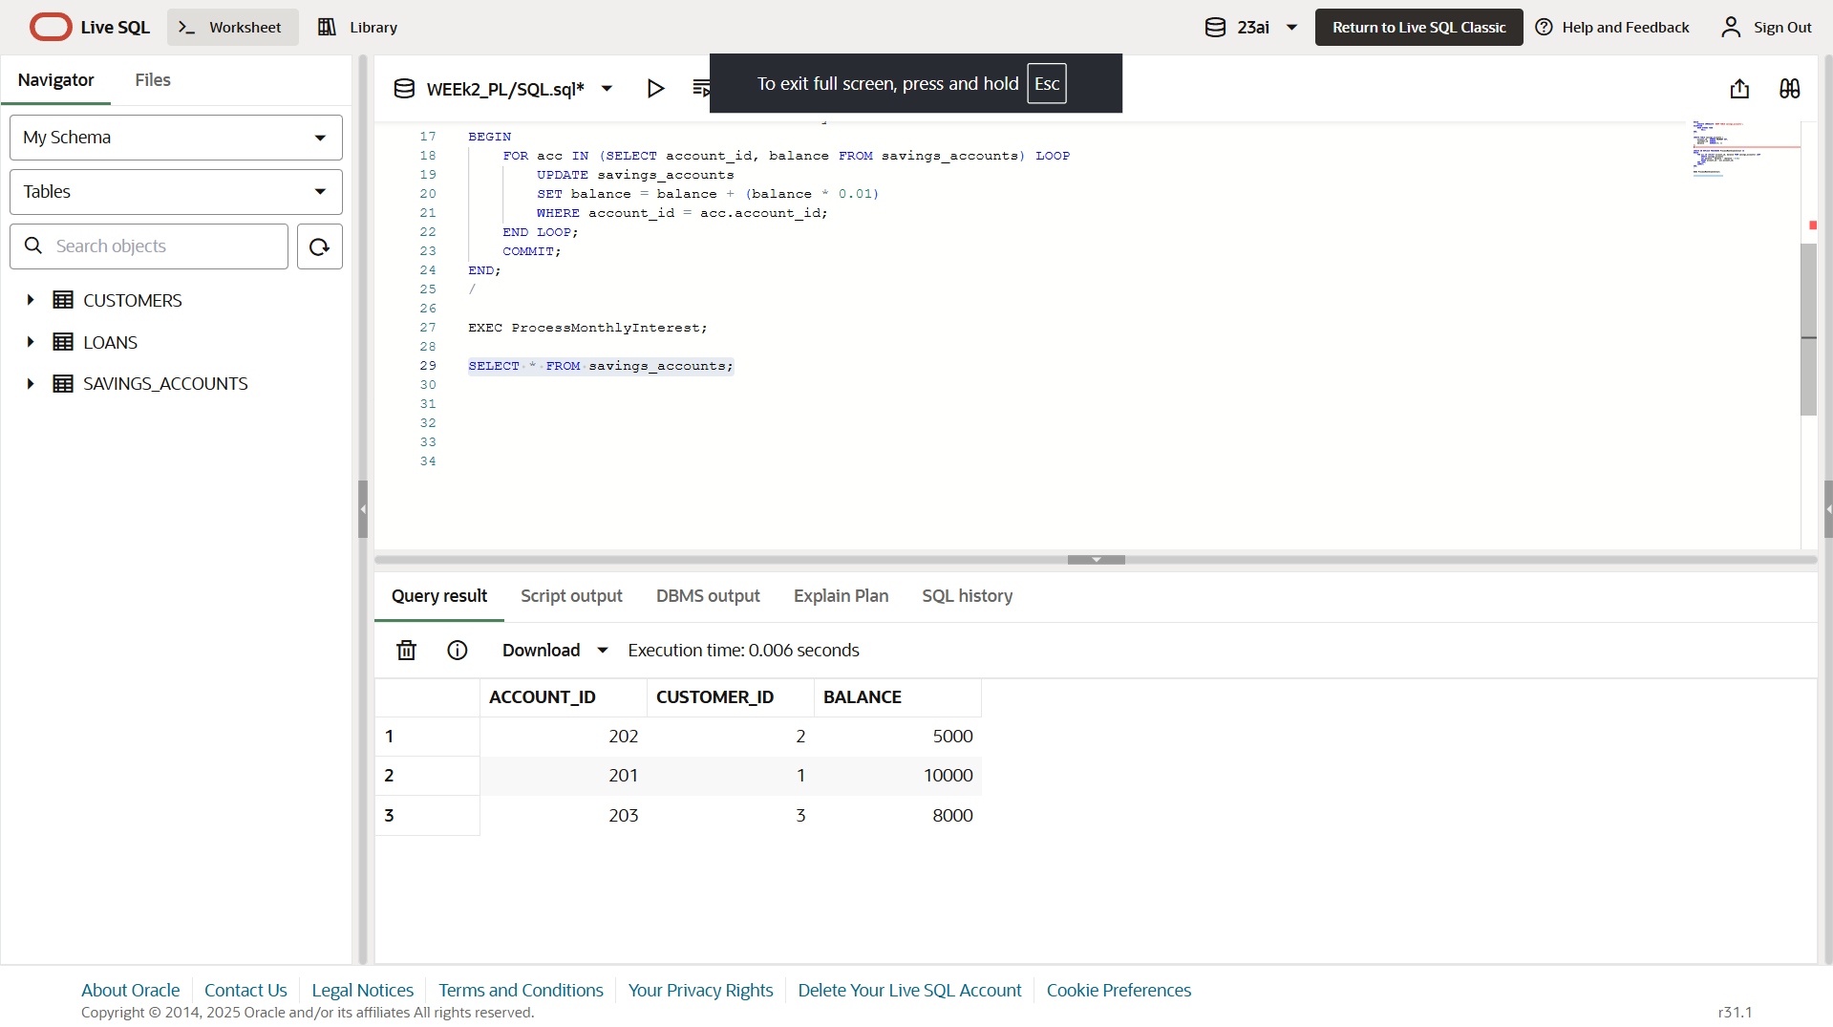

**Scenario 3:**

CREATE OR REPLACE PROCEDURE TransferFunds (

from_account_id IN NUMBER,

to_account_id IN NUMBER,

amount IN NUMBER

) IS

from_balance NUMBER;

BEGIN

SELECT balance INTO from_balance

FROM accounts

WHERE account_id = from_account_id;

IF from_balance < amount THEN

RAISE_APPLICATION_ERROR(-20001, 'Insufficient balance in source account.');

END IF;

UPDATE accounts

SET balance = balance - amount

WHERE account_id = from_account_id;

UPDATE accounts

SET balance = balance + amount

WHERE account_id = to_account_id;

COMMIT;

END;

/

EXEC TransferFunds(301, 302, 2000);

SELECT * FROM accounts;

**OUTPUT:**

